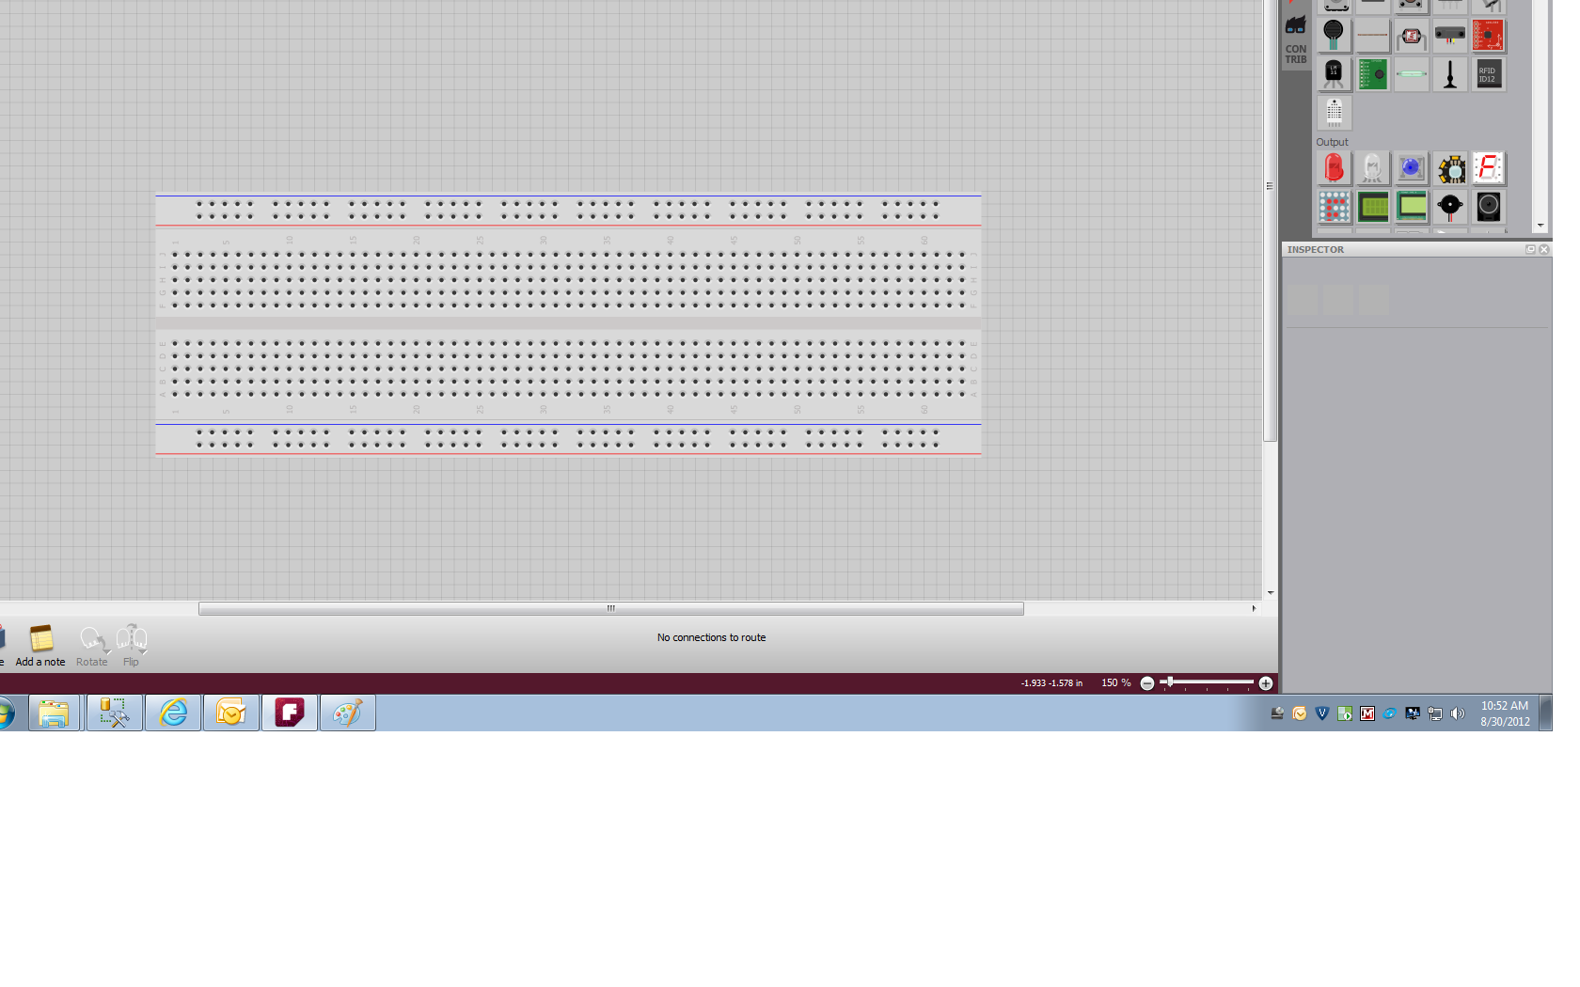I’m Alive  
Basic Breadboard Setup  
  
1) Start with board aligned highest numbers at top.

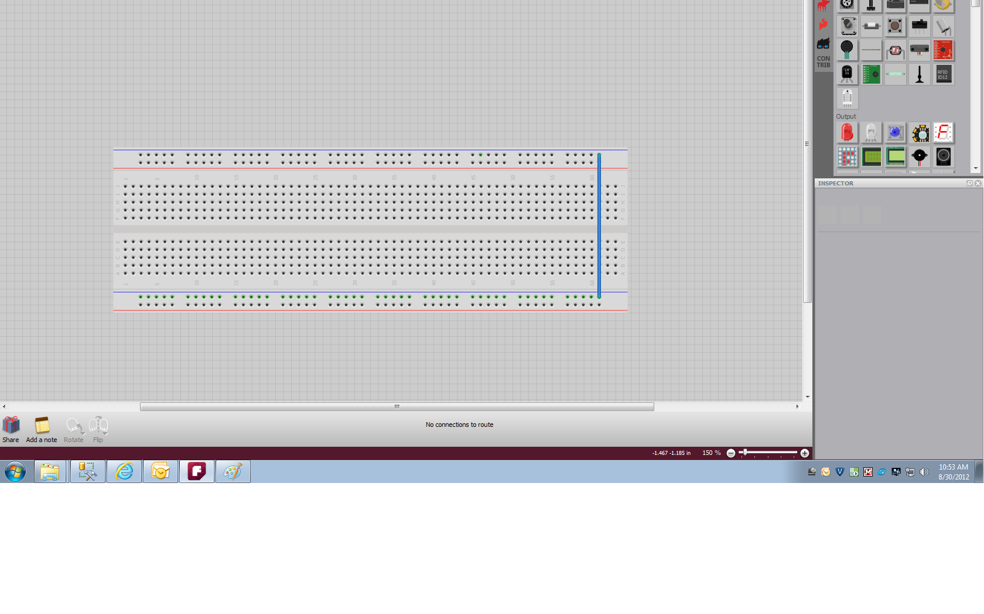

2) Tie negative rails together.

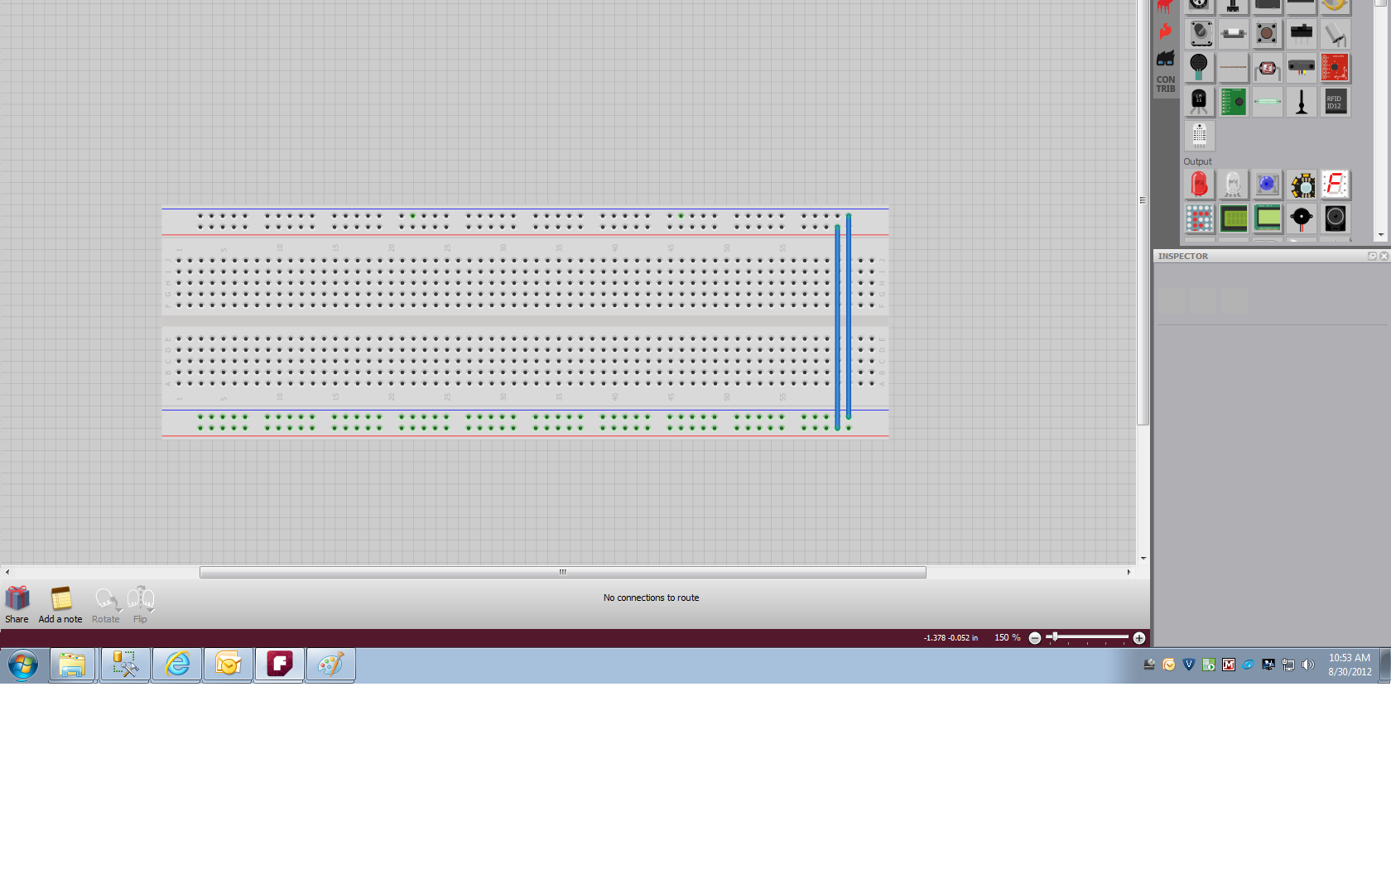

3) Tie Positive rails together.

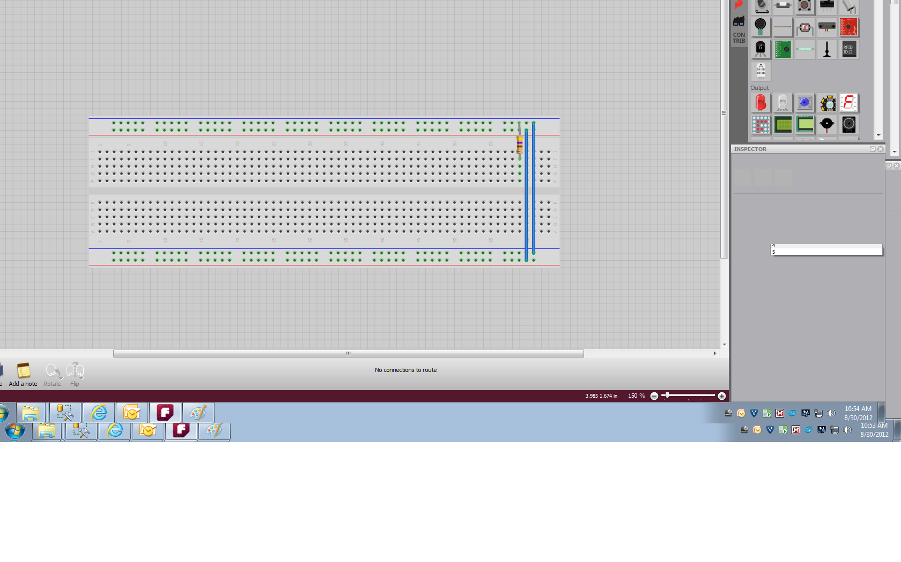

4) Insert 470 Ohm Resistor from Negative Rail to J.

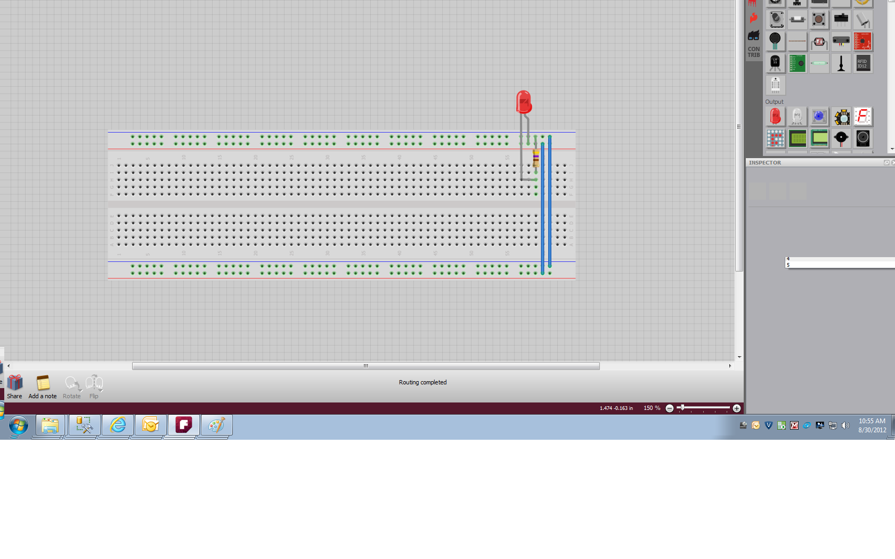5) Insert LED from Positive Rail, Long lead, to I Row, Short Lead.

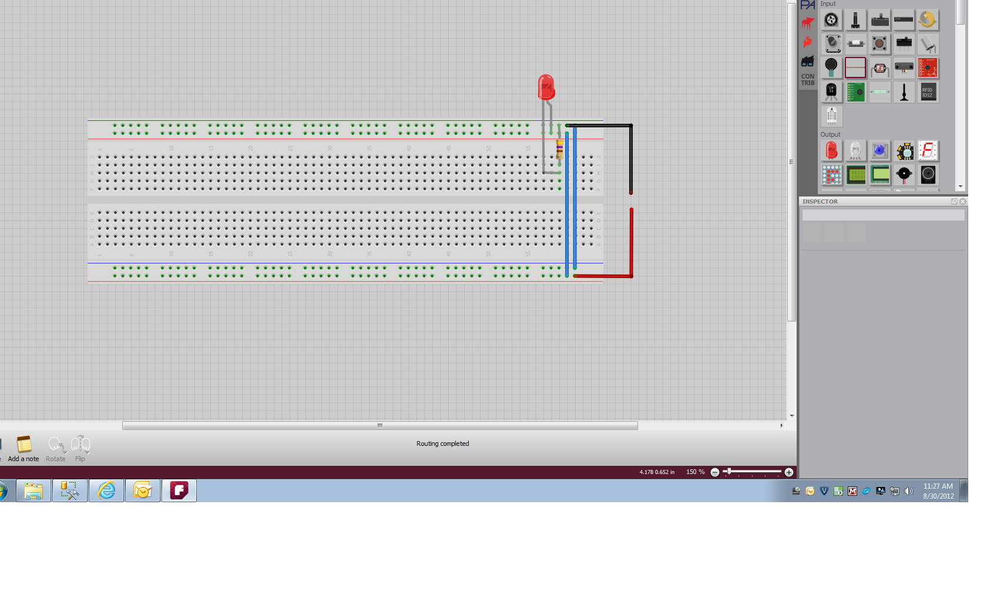

6) Attach Battery Clip red positive lead to Red, Positive Rail.  
Attach Battery Clip black negative black lead to Blue, Negative Rail.

7) Attach Battery  
LED should light.